Mastering Precision: Exploring the Power of

CNC Machining Services for Custom Parts

# Introduction to CNC machining

Machining operations seem easy, simple and possible now because of Computer numerical control (CNC) machining, a subtractive manufacturing process that removes layers of material from a job piece in order to produce a customized part using materials like metals, plastics, wood, glass, foam, and composites. It can also be used in telecommunications business and aircraft parts, which have higher tolerances, compared other industries.

|  |  |
| --- | --- |
| C:\Users\DELL\Desktop\download.jpg | The origin of CNC milling |

Figure 1: CNC machining

## Importance of CNC Machining in Custom Parts Production

CNC machines are extremely advantageous, which is why CNC parts have grown in popularity in the automotive, aerospace, medical, manufacturing, and defense sectors.

### Optimal Productivity

CNC machines are computerized which is why they don’t rely upon manpower once the setup is done. Therefore, CNC machining offers increased productivity than other machines.

### Agile Technology

CNC machines allow the production of sophisticated custom parts at reasonable cost. At low cost, this machining also allows for the design change as per the customer's needs.

### Fast production

CNC machines are computerized using special software, which obviously results in fast fabrication of customized parts. With CNC machining, not only manual labor is reduced but consistency of parts for low-medium volume production is also ensured.

### Cost-effective

CNC machines have lower labor costs, boosted productivity, and timely meeting of delivery rates due to its faster production rates.

### Ideal for prototyping

Rapid prototyping is one of the features of CNC that makes it different from other methods of production. With rapid prototyping, the designs can be tested on a small scale and defects can be corrected. This allows the production owners to overcome long term while enabling them to reach smaller customers.

### Compatible with a diverse array of materials

CNC is flexible in terms of materials; it can work with almost all sorts of materials like metals, plastics, ABS, ceramics, foam, wood, composites etc.

### Maximizes efficiency and accuracy

CNC machining results in faster production, high level of production and since it is customized it also results in accurate productions (free of human error). These all characteristics results in maximized efficiency.

### Safer production

Manpower is only required for initiating the machine for the setup. Manpower is not exposed to the machine during the fabrication process which makes CNC machine an epitome of safer production.

## Understanding CNC Machining

For video (reference): <https://www.youtube.com/embed/v4jwVdFsoGo>

The step by step process of CNC machining is:

* Create a CAD model displaying tolerance, construction lines, threads, etc.
* Then the CAD model is to be converted into a CNC-compatible format, which can be done using CAM tools like AutoCAD, Fusion 360, etc.
* In the final step, machining process will be started by the operator when he/she attaches the required cutting tools.

Microprocessor is the main constituent of CNC machines that is attached to the tool in order to control it. The G-code and M-code programming language are used in CNC to feed the information about feed rate, spindle speed, cutting tool, and coolant flow to the microcomputer. All data processing is done in the MCU, (MCU creates motion commands and delivers them to the drive system). The feedback signals received in MCU are compared to the standard signals where if any faults are detected, new signals are transmitted to the machine tool to carry out the required actions.

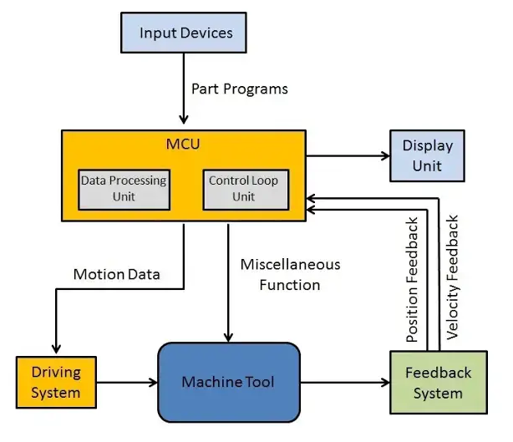

Figure 2: Schematic representation

There are a variety of CNC machines like CNC milling machines, CNC lathes, CNC routers, CNC plasma cutters, CNC electric discharge machines, and CNC laser cutters.

## Key considerations in CNC Machining

1. **Material Selection for CNC Machining**

The selection of materials impacts the whole process of machining; its entire lifecycle including prototyping, production, defects, repairs etc. Identifying the material requirements, exploring potential materials, and then choosing the most suitable material are key considerations in ensuring best product outcomes.

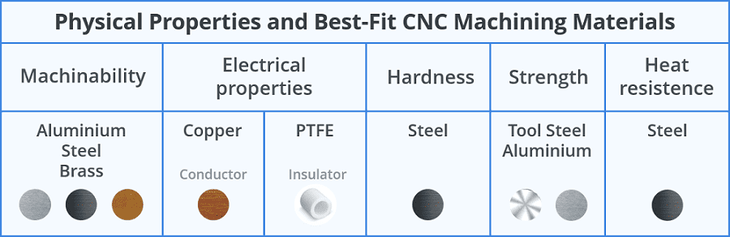

The selection of the right material for CNC machining projects involves considering several important factors such as:

1. Application

Different application require different kinds of material properties. Some application may require high ductility, whereas some may require brittleness, some may require high strength, and some may require greater toughness and so on. Aluminum is used in the aerospace industry as it has high strength-to-weight ratio.

1. Operating conditions

Materials may react differently in different operation conditions such as temperature variations, exposure to chemicals, UV radiation, water contact, and flame resistance. Proper understanding of the effect of environment conditions with the materials is required.

1. Dimension / Tolerance

Industries like aerospace require dimensionally stable components with precise tolerances. The materials those are malleable, ductile, properties that make them machine-able are preferred in these industries.

1. Electrical Conductivity

Some applications may require the material to have high conductivity while some process may require them to have insulating properties. For excellent conductivity, materials like copper, silver can be used and for insulating properties, PTFE (polytetrafluoroethylene) may be chosen.

1. Physical Appearance

Some customers may prioritize the aesthetics of the finished production as their major requirement. Depending on your customer's desire, maintaining the physical appearance and focusing on secondary finishing operations may also be essential.

1. Cost

Whatever a customer is paying for the product, it should be worthwhile of their time and money. Materials with better properties and failure resistance are expensive. Careful evaluation of the toughness, strength, hardness, wear resistance, corrosion resistance etc. is necessary to determine if a material can serve as a cost-effective alternative.

1. Availability

Proper research regarding the availability of the materials is to be done before finalizing the material. A material can have everything your process requires, but if it is not available abundantly, that material has to be replaced with one that is available to you locally or in some easy, indirect ways.

### Design Considerations for CNC Machining

1. Inner Edges

While dealing with inner edges, a vertical corner radius should be of at least 1/3rd of the cavity depth. Slightly larger corner radius results in higher surface finish quality.

1. Thin Walls

|  |  |
| --- | --- |
| **Materials** | **Wall thickness** |
| Metals | 0.8mm |
| Plastics | 1.5mm |

If the wall thickness is decreased, it causes the decrement of stiffness of material. This in turn causes vibrations to increase which results in higher errors. Recommended wall thickness values are

1. Holes

According to design recommendations, flat-bottom holes should be avoided as much as possible. To make deeper holes, specialized drill bits (minimum diameter of 3 mm) are employed.

1. Smaller Features

Similar to the flat-bottom holes, micro-machining (process of creating cavities and holes having diameter of less than 2.5 mm) is recommended to be avoided unless absolutely required.

1. Chamfers & Fillets

Chamfer edges are recommended to be at a standard 45° angle unless some other angles are absolutely necessary. For fillets, the radius of interior fillets is recommended to be higher than 1/3rd of the depth of the cavity for preventing tool breakage.

### Quality Control in CNC Machining

In order to maintain quality by ensuring the production of defect-free products, dimensional accuracy and quality, mitigating risks and costs, and enhancing productivity, quality control is of absolute importance that can be carried out using following processes.

1. Customer communication

In a manufacturing business, customers have to be our number one priority. Communicating with them about their needs and demands, keeping them happy with quick contact after receiving a customer inquiry and sending samples is a main requisite in this field.

1. Understand the design of the product

After receiving the CAD drawings, engineers responsible for CNC machining should thoroughly evaluate the design, understand the product specifications, and double check all the details before initiating manufacturing process.

1. Product and service

The machinist should keep in mind that the main goal is to provide the customers better and unique product with reasonable pricing. From the procurement process to inspection and testing, all procedures play important role in ensuring the top notch quality of the products and services.

1. Verification of purchased products

To detect the visible effects, the inspector inspects all purchased products.

1. Process inspection

Process inspection can occur at any point along the manufacturing and production cycle. It is done to assure quality and ensure timely delivery of finished orders.

1. Final inspection

During the final quality control (QC) inspection, only products that pass the final inspection procedure can be packaged and dispatched to the customers. Documentation of all the inspection and testing findings is done during this process.

## Choosing a CNC Machining Service for Custom Parts

Before choosing a particular CNC machining service, it is vital to consider several factors such as:

### Cost and turnaround time

A customer has a set budget and timetable for their projects. The CNC service they select should be able to work with this cost and timeframe.

### Manufacturing Capability

Before choosing a vendor for CNC machining process, reviews of other customers, their history etc. should be assessed by the customers. Vendors should be prepared to demonstrate why they are the better choice and why they should be chosen over other potential vendors.

### Communication

Ask these questions to all the potential vendors before selection of one.

* What is the average turnaround time for a CNC project like mine?
* Do you have prior experience in cutting the materials that my project requires? Can you provide me the information regarding the type of tools and materials that you usually work with?
* What are the limits of the size of an object that can be cut?
* What kind of axis does your CNC machine possess (5th, 6th, or 7th)?
* Do you outsource your work? If yes, what platform do you use?
* Are there any other services that you provide?

## Future trends

### Use of Plywood in Laser Cutting

Creation of geometric patterns and etch designs on wood is possible nowadays, all thanks to CNC laser cutting techniques that helps in maintaining the strength, flexibility and durability of milled wood.

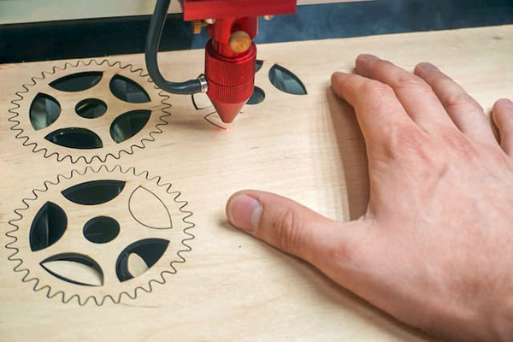

Figure 3: Laser cutting wood

### BoXYZ

BoXYZ machine is the one that combines two technologies of 3D printing and CNC machining. It is an all-in-one device that integrates a CNC mill, a laser engraver, and a 3D printer. Because of its versatility in work, it is tremendously growing in popularity.

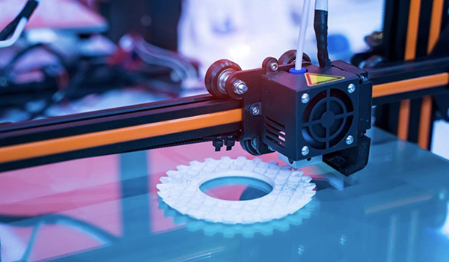

Figure 4 BoXYZ machining

### Machining Ice

Japan has started using CNC machines in order to create intricate sculptures out of ice. By converting vector information into G-code and M-code, CNC machines care now able to mill ice into detailed and beautiful shapes.

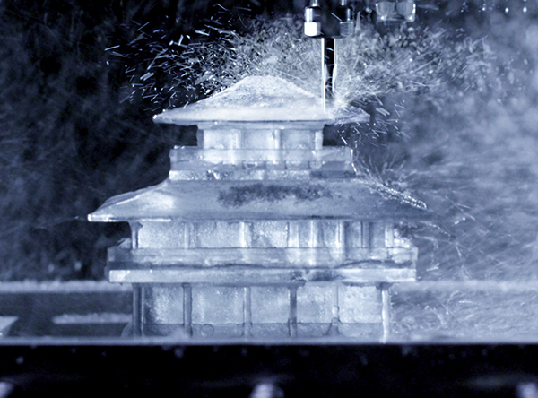

Figure 5 Ice machining

### Machine Alerts on Smartphone

It is not necessary to watch the machining process to receive updates on where the process is at. A system has been developed in your smart phones that can send alerts through texts, emails. It is capable of sending the users real-time information about the condition and status of their machines.

# Conclusion

CNC machining services have revolutionized the production of custom parts by offering unparalleled precision, speed, and versatility. This advanced technology empowers businesses and individuals to bring intricate designs to life with exceptional accuracy and efficiency. With the capability to work with a wide range of materials and provide extensive customization, CNC machining fosters innovation and facilitates the creation of high-quality, distinctive parts.

Mastering Precision: Exploring the Potential of

CNC Machining Services in Custom Parts

1. Introduction to CNC machining

Machining operations now seem easy, simple, and possible because of Computer Numerical Control (CNC) machining. It is a subtractive manufacturing process that removes layers of material from a job piece to produce a customized part using materials such as metals, plastics, wood, glass, foam, and composites. Besides, with such machining in telecommunications business and aircraft parts, there are higher tolerances than others. An example of CNC machining is shown in Figure 1.

1.1. Importance of CNC Machining in Manufacturing Custom Parts

CNC machines are much helpful, for this reason, CNC parts are highly demanded much in the earlier days from the automotive, aerospace, medical, manufacturing as well as with defence-based industries.

a) More productivity

CNC machines are automated. Therefore, these are not relying on the labourers after they had made their adjustments. Therefore, CNC machining is more productive than any other machining.

b) Flexible technology

CNC machines make it possible to produce complex parts at affordable cost. This machining also makes design change cheaply at low cost as dictated by the customer.

c) Fast fabrication

CNC machines are computer-controlled with special software and thus speeds up production of special parts. The manual work developed through CNC machining is not only at a faster rate but also consistency of parts for low-medium volume production is achieved.

d) Economical

Human-in-the-loop

CNC machines provide lower labor costs, a boost in productivity, and the timely meeting of delivery rates due to its faster production rates.

e) Ideal for prototyping

Rapid prototyping is one of the features of CNC that makes it different from other methods of production. Through rapid prototyping, small–scale tests of the designs may be run and defects can be changed. This enables the owners of the productions to overcome long–term defects while making it possible to access smaller customers.

f) Compatibility with a wide variety of materials

CNC is flexible concern the material; it can work through almost all sorts of materials like metals, plastics, ABS, ceramics, foam, wood, composites etc.

g) Maximizes efficiency and precision

CNC machining results at faster production, high level of production and since it is customized it also results in precision productions (free of human error). All these characteristics result in maximized efficiency.

h) Safe production

Manpower is only needed to trigger the machine for the setup. The machine does not expose manpower to the machine during the process of fabrication which makes the CNC machine is the example of safer production.

1.2. Understanding CNC Machining

For video (reference): https://www.youtube.com/embed/v4jwVdFsoGo

The process to machine by CNC is a step by step process everyone should know.

• Create a CAD model showing tolerance, construction lines, threads, etc.

• In this step, the CAD model can be converted into a CNC-compatible format, using CAM tools such as AutoCAD, Fusion 360 etc.

• In final step, the process of machining will be initiated by the operator when he/she fixes necessary cutting tools required to get initiated. Microprocessor is the central element of CNC machines which can be fixed to the tool to operate the tool using CNC. The feed rate, spindle speed, cutting tool, and flow of coolant information are all fed into the microcomputer using the G-code and M-code programming language. All data processing with respect to feed rate, cutting tool, and flow of coolant is carried out at the MCU. (MCU creates motion commands and delivers them to the drive system). The feedback signals received in MCU are compared to the standard signals where if any faults detected new signals are transmitted to the machine tool to carry the necessary actions.

Figure 2: Schematic representation

There are various types of CNC machines such as CNC milling machines, CNC lathes, CNC routers, CNC plasma cutters, CNC electric discharge machines, and CNC laser cutters.

1.3. Important aspects of CNC Machining

a. Material Selection for CNC Machining

The material selection affects the overall machining process; its complete life cycle during prototyping, production, defects, repairs, etc. From finding the list of material requirements, investigating potential materials, followed by the choice of the right material, is a fundamental consideration in securing the best product outcomes.

The art of selecting the right material for a CNC machining job requires consideration of quite a few important factors, such as: conclusion

Material property requirement: Different applications require different kinds of material properties. Some applications may require high ductility, while others may require brittleness, some may require high-strength, and some may require greater toughness, among others. In the aerospace industry, there is a use of aluminum since it has a high strength-to-weight ratio.

b)

Materials may react to different operation conditions, such as temperature variation, exposure to chemicals, UV radiations, the contact of water, and flame resistance. It requires proper understanding of the effect of environment conditions with the materials.

c) Dimension / Tolerance

Industries like the aerospace require dimensionally stable components with precise tolerances. The materials those are malleable, ductile, properties that make them machine-able are considered preference in these industries.

d) Electrical Conductivity

Some applications may need the material to be high in conductivity, while some processes may need them to be insulating in nature. For excellent conductivity, materials like copper and silver can be used and for insulating in nature, PTFE may be chosen.

e) Physical Appearance

Some clients may have completed production aesthetics as their main necessity. Depending on your client's demand, some requirements may require you to specialize in maintaining the physical appearance and others need you to on secondary finishing operations.

f) Cost

Whatever a client is paying for the product, rather it should be worth of their time and money. Expensive are the materials with better properties and failure resistance. Enough care should evaluate the toughness, strength, hardness, wear resistance, corrosion resistance etc. so that if the material has the potential for replacing the material in process, it can do so cost effectively.

g) Availability

Proper research regarding the availability of the materials is to be done before finalizing the material. A material can have everything your process requires, but if it is not available abundantly, that material has to be replaced with one that is available to you locally or in some easy, indirect ways.

b. Design Considerations for CNC Machining

a) Filleted Inner Edges

While dealing with the inner edges, a vertical corner radius should be of at least 1/3rd of the depth of the cavity. Slightly larger corner radius turns in higher surface finish quality.

b) Thin Walls

Materials Wall thickness

Metals 0.8mm

Plastics 1.5mm

If the thickness will be lesser, then this will cause decrement of stiffness of material. This in turn causes vibrations to increase which is resulted in higher errors. Recommended thickness of wall is

c) Holes

It is required to use flat end pockets/shapes as less as possible. For deeper pockets, a specialty drill needs to be used (the minimum diameter is 3 mm).

d) Smaller FeaturesMicro-machining needs to be avoided as much as possible as for the flat pockets. Micro machining is machining to remove material and it usually creates cavities in holes with a diameter less than 2.5 mm.

e) Chamfers & Fillets

Chamfer edges should all be the standard 45° unless there's an urgency of other angles. For fillets, radius of the inner fillet is recommended to be greater than 1/3rd of the depth of the cavity so that the tool does not break.

c. Quality Control in CNC Machining

For the purpose of producing defect-free products, dimensional accuracy and quality to preclude latent liabilities of defects that might arise out of the production of products, avoiding risks and costs and enhancing productivity, be of utmost importance that quality control can be assured by the following processes.

a) Customer communication

Our customers have to be the top priority in a manufacturing business. In this set up, it is a major requirement to talk to the customers about their needs and demands to keep them satisfied. Contacting them at the earliest once a customer inquiry is received and sending samples would be one of the main requirements.

b) Comprehend the design of the product

After CAD drawings are received, CNC machining engineers should analyze design, product specification with deep care, cross verify minute details carefully, and only then start the production process.

c) Product and Service

The machinist should always keep in mind that the ultimate purpose therein is to make a customer satisfied with the better and unique product with a reasonable price value. All the procedures starting from procurement to inspection test all these are vital in ensuring top-quality products and services.

d) Verification of purchased products

To determine the apparent effects, the inspector inspect all purchased products.

e) Process inspection

Process inspection can be carried out at any stage in the manufacturing and production cycle. The same is used with the intention to maintain quality and ensure that completed orders are delivered on time.

f) Final inspection

Only those articles which are made to pass the final quality control (QC) inspection can be accurately packaged and sent to the clients. Documentation of results of all the inspection and testing results is done with this procedure .

1.4. Choosing a CNC Machining Service for Custom Parts

What to be Considered before Picking on CNC Machining Service

Before settling on a specific CNC machining service on needs to pay solace to the following

a) Cost and turnaround time

A customer has a limited budget and time frame for their projects. The CNC service they are trying to contract will need to abide by this cost and time frame.

b) Capability of Manufacturing

Before choosing the supplier for the CNC machining process, customers should evaluate the feedback from the customers, background and so on. Customers should get the feel of the vendor being desirous of explaining why they are better and why one should go ahead with them in place of another set of potential vendors.

c) Communications

The customer should ask the following questions from all the potential vendors before zeroing on one.

➢ What is the industry lead‐time for such CNC project ?

➢ Have you done the cutting on the material that I will need for my project? Could you please provide the details on the type of tools and material you usually work with?

➢ What size of an object cut is not possible?

➢ What kind of axis does your CNC machine have (5th, 6th, or 7th)?

➢ Do you outsource your work? If yes, what platform do you use?

➢ Do you offer any other services?

1.5. Future trends

a) Plywood and Laser Cutting

The tendency to receive geometric patterns and edict designs on wood is simple to carry out these days due to CNC laser cutting methods that help in keeping the wood milled with that particular strength, flexibility, and milled.

Figure 3: Laser cut wood

b) BoXYZ

BoXYZ is the machine that fuses both technologies of 3D printing and CNC machining. It is a standalone device mounting CNC mill, laser engraver, and 3D printer. Since it is versatile at work, it is very fast growing in popularity.

Figure 4 BoXYZ machining

c) Machining Ice

This has consequently made Japan adopt the use of CNC machines in converting various sculptures from ice. By converting the vector information into G-code and M-code, the CNC machines are now able to mill the ice into detailed, beautiful shapes.

Figure 5 Ice machining

d) Machine Alerts on Smartphone

Updates on the stage at which the machining process might be at are gotten without necessarily monitoring the process of machining. A system has been developed in your smartphones that can send alerts through texts, emails. The system is able to send the rate at which the process of machining might be going on. It can send the users with real-time information about the condition and status of their machines.

2.Conclusion

CNC machining services further extend this custom part manufacturing with unrivaled precision, speed, and flexibility. Advanced Technology means really real freedom and opportunity for business and personal crazy, intricate designs to come alive with incredible precision and time savings. Since CNC machining works with various materials and offers huge customization possibilities, it drives innovation and drives the making of high-quality, very unique parts.